**Bigdata Assignment 2.8**

* entered into hive shell by using command -

**start-all.sh**

**hive**

* Then in the 'custom' database , we created a external temporary table named temp_table and loaded the data into the tablefrom the text file loacted in the local file system.

Command used -

**use custom;**

**CREATE EXTERNAL TABLE IF NOT EXISTS temp_table(full_date string,zipcode , temp int) ROW FORMAT DELIMITED FIELDS TERMIBATED BY ',' ;**

**LOAD data local inpath 'dataset_Session 14.txt' overwrite into table temp_table;**

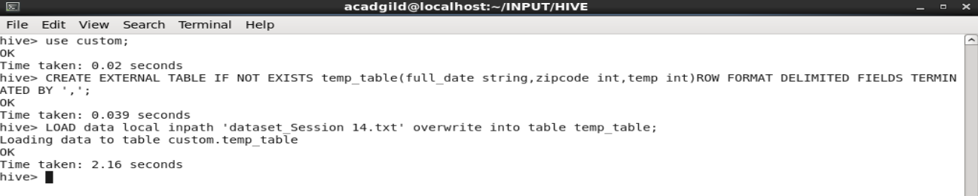

* Then we checked the contents of the table as it can be ssen int he below screenshot the date format is dd-MM-yyyy.

**select * from temp_table;**

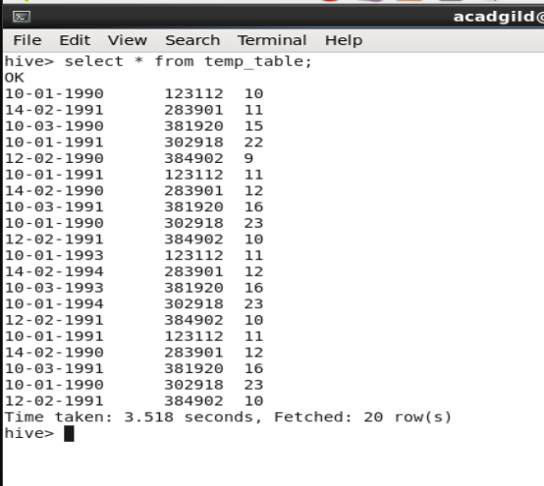

* We created actual table to store the correct date format data .

**CREATE EXTERNAL TABLE IF NOT EXISTS temperature_data(full_date timestamp, zipcode int, temp int) ROW FORMAT DELIMITED FIELDS TERMINATED BY ',' ;**

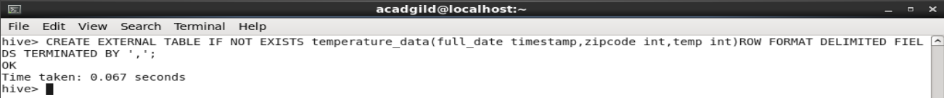

* Inserted the data into new table 'temperature_data' from the previous table temp_table using unix_timestamp function.

**INSERT OVERWRITE TABLE temperature_data SELECT from_unixtime(unix_timestamp(full_date,'dd-MM-yyyy')), zipcode , temp from temp_table;**

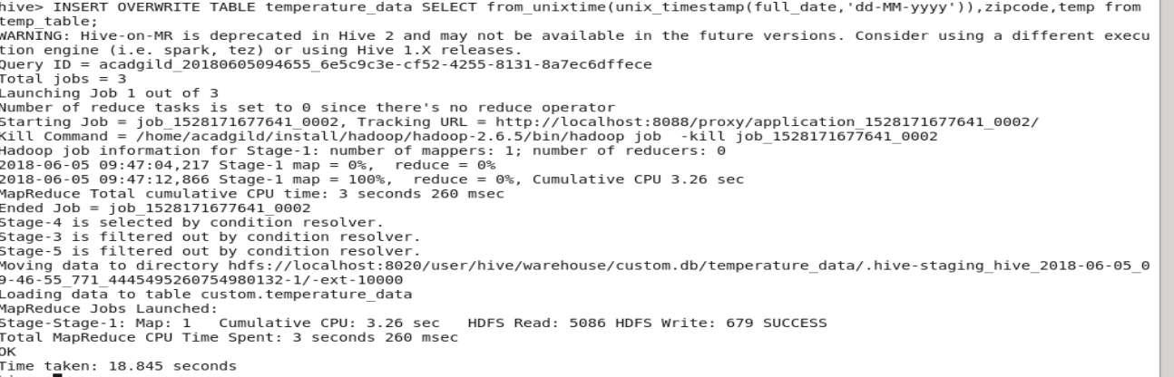

* After inserting the data , we checked the content of the table

**select * from temperature_data;**

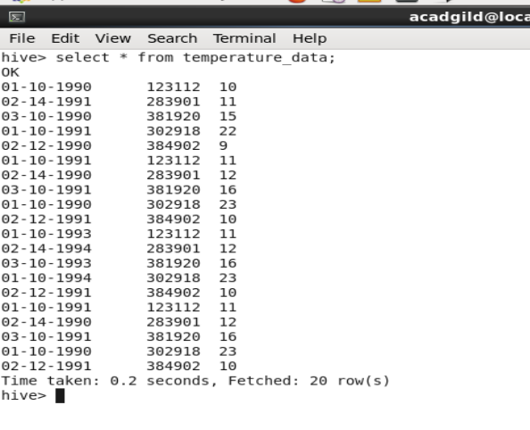

1. Fetch date and temperature from temperature_data where zip code is greater than 300000 and less than 399999.

Ans - **select full_date , temp from tempearture_data where zipcode>300000 and zipcode<399999;**

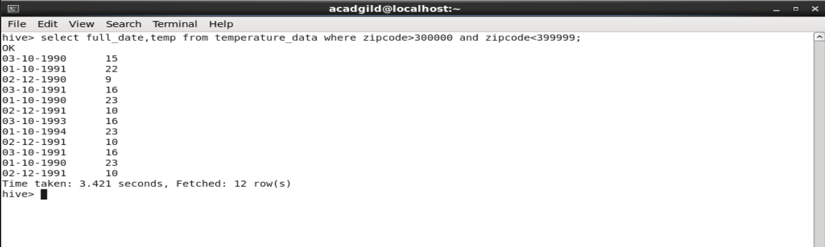

2. Calculate maximum temperature corresponding to every year from temperature_data table.

Ans – **select year(full_date) , MAX(temp) from temperature_data GROUP BY year(full_date);**

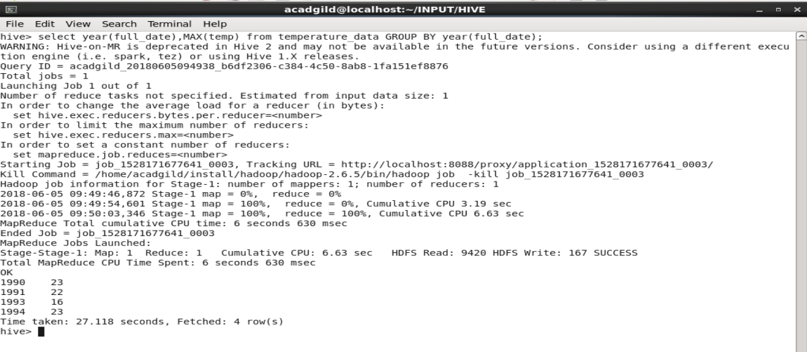

3. Calculate maximum temperature from temperature_data table corresponding to those years which have at least 2 entries in the table.

Ans - **select year(full_date) , MAX(temperature)_data GROUP BY year(full_date) HAVING COUNT(year(full_date))>=2;**

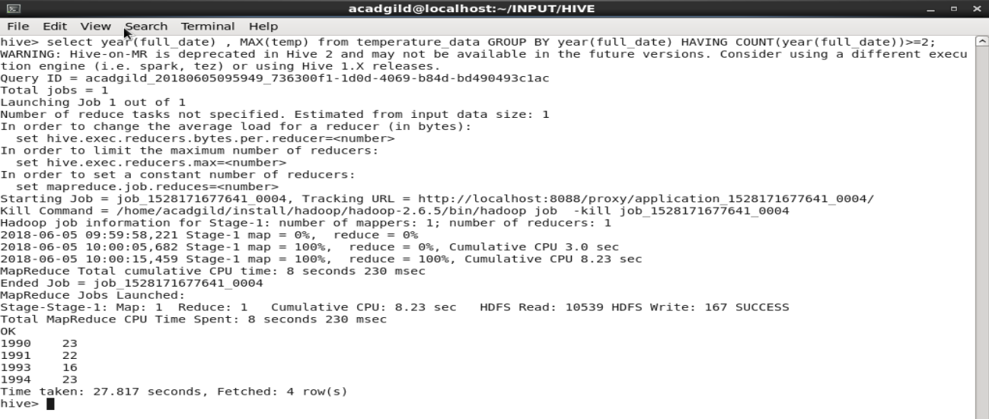

4. Create a view on the top of last query, name it temperature_data_vw.

Ans – **CREATE VIEW tempearture_data_vw as select year(full_date) , MAX(temp) from tempearture_data GROUP BY year(full_date) HAVING COUNT(year(full_date))>=2;**



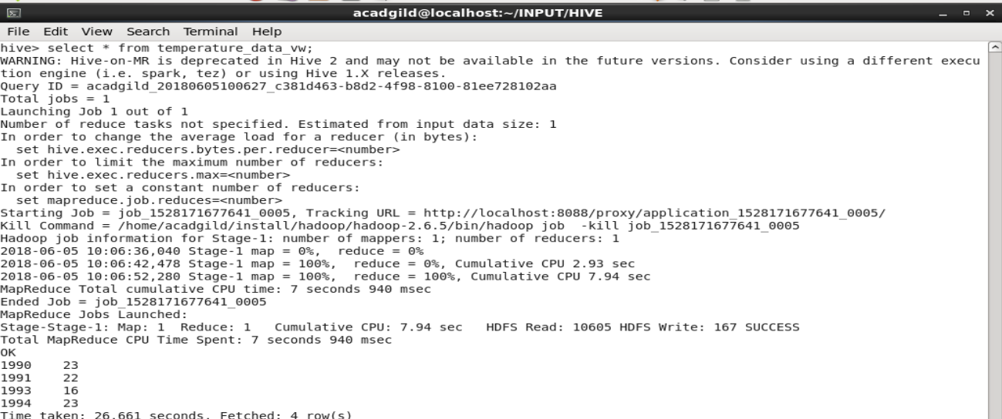

5.Export contents from temperature_data_vw to a file in local file system, such that each file is '|' delimited.

Ans – **INSERT OVERWRITE LOCAL DIRECTORY 'home/acadgild/INPUT/HIVE/tempearture_data_vw.txt' ROW FORMAT DELIMITED FIELDS TERMINATED BT '|' select * from temperature_data_vw;**



**The content of the file is shown in the below screenshot.**

